MRARegress

Beta version, the package and its "User Manual" are not yet published, but the paper is under preparation.
Here is a short documentation :
The principle of MRA is shown in the following figure, concerning a 3-nodes network (a node may represent a gene, a transcript or a protein, for instance) :
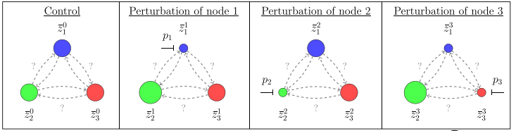
- Measure the expression level of each node, without any perturbation, when everything is stable (we call this "basal state" or "control"). Note these values as $z_{1}^{0}, z_{2}^{0}$, $z_{3}^{0}$.
- Apply a perturbation that acts on node 1 only (called "p₁" on the figure). Measure the expression level of each node when the steady state is reached. Note these values as $z_{1}^{1}, z_{2}^{1}$, $z_{3}^{1}$.
- Do the same with nodes 2 and 3.
- Put the results in a matrix $\left[\begin{matrix}z_{1}^{0} & z_{1}^{1} & z_{1}^{2} & z_{1}^{3} \\ z_{2}^{0} & z_{2}^{1} & z_{2}^{2} & z_{2}^{3} \\ z_{3}^{0} & z_{3}^{1} & z_{3}^{2} & z_{3}^{3}\end{matrix}\right]$. We call this matrix "MatExp" (for "Experimentation Matrix").
Among several things, MRARegress returns a "Connectivity Matrix", called "r", which measures the action of one node on another one. For example, $r_{i}^{j}$ (row i, column j) represents the action of node j upon node i.
Under some assumptions, we have shown that :
$(ΔX1)_{p_{2}}≈r_{1}^{2}*(ΔX2)_{p_{2}}+r_{1}^{3}*(ΔX3)_{p_{2}}$. What are $(ΔX1)_{p_{2}}$, $(ΔX2)_{p_{2}}$, $(ΔX3)_{p_{2}}$ ?
You may choose between two possibilities (this is an input parameter of MRARegress) :
- "Relative" values (like aiMeRA did) : $(ΔX1)_{p_{2}}=2*\frac{z_{1}^{2}-z_{1}^{0}}{z_{1}^{2}+z_{1}^{0}}$ and so on for $(ΔXk)_{p_{l}}$ or
- "Absolute" values : $(ΔX1)_{p_{2}}= z_{1}^{2}-z_{1}^{0}$ and so on for $(ΔXk)_{p_{l}}$.
Of course, the values of $r_{i}^{j}$will depend on your choice. Then, you can draw a graphical representation of these interactions :
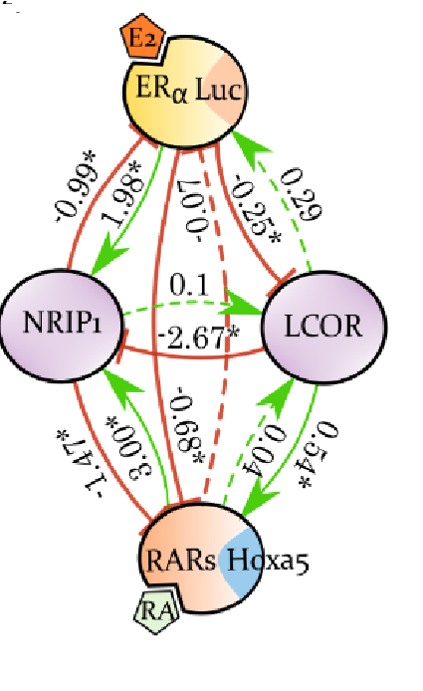 | $$r= \left[\begin{matrix}-1 & -0.99 & 0.29 & -0.07 \\ +1.98 & -1 & -2.67 & 3.00 \\ -0.25 & 0.05 & -1 & 0.04 \\ -0.68 & -1.47 & 0.54 & -1\end{matrix}\right]$$  Connectivity Matrix corresponding to the figure on the left, "Relative" values. You may notice that $r_{i}^{i}$ is not defined and is set to -1.  Node 1 = ERα  Node 2 = NRIP1  Node 3 = LCOR  Node 4 = RARs

To install "MRARegress" (to be done once) :
- Check, and update if necessary, "R" (version ≥ 4.3.0) and "RStudio" (version ≥ 2023.06.0 )
- If you use "Cytoscape" (to draw graphs), check version, and update if necessary (≥ 3.10.1)
- Start RStudio
- Install package "devtools" : install.packages("devtools")
- Install package "minet" :
if (!require("BiocManager", quietly = TRUE))
install.packages("BiocManager")
BiocManager::install("minet")
At question " Update all/some/none? [a/s/n]: ", answer "a"
- Install package "RCy3" :
BiocManager::install("RCy3")
At question " Update all/some/none? [a/s/n]: ", answer "a"
- Install package "MRARegress" : devtools::install_github("J-P-Borg/MRARegress")
The packages "devtools", "minet", "RCy3" and "MRARegress" should now appear in the RStudio package list (at the bottom right of the screen).
When "MRARegress" is installed, with RStudio you can :
- display the documentation :
library("MRARegress")
?MRARegress
- use this package.
Many input parameters exist, they are described in the doc. on line. Most of them have a default value corresponding to simple and usual uses.
For example, once you have completed the "Experimentation Matrix" (MatExp) with your data, you will get the "Connectivity Matrix r" by :
Res = MRARegress (MatExp)
r = Res$r
Would you like to see the network drawing ?
Launch "Cytoscape", then inside RStudio, enter :
A = DrawGraph(Res)
Inside Cytoscape, you may move the nodes in the map to improve the drawing. Just left click on a node and move it with the mouse.
You may try these possibilities with the previous 4-nodes network, shown above. In RStudio :
Load the file "Demo_4nds.rda" : load ("Demo_4nds.rda")
The corresponding "MatExp" is called "Demo". To see it, type : Demo
Then : A = MRARegress(Demo) and A$r to see the connectivity matrix.

Thank you for your interest in our package. Don't hesitate to call us for any help or question.

Jean-Pierre BORG

